FOOD/INSECT & EMERGENCY ALLERGY CARE PLAN and MEDICATION AUTHORIZATION
Connecticut State Law and Regulations 10-212(a) require a written medication order of an authorized prescriber, (physician, dentist, optometrist, advanced practice registered nurse or physician's assistant, and for interscholastic and intramural sports only, a podiatrist) and parent/guardian written authorization, for the nurse, or in the absence of the nurse, a qualified school personnel to administer medication.
BEECHER ROAD SCHOOL
STUDENT INFORMATION | ^{Student Name} | ^{DOB:}
 | ^{Home/Cell Phone} | ^{Grade}
 | Known Life-Threatening Allergies:  Diagnosis of Oral Allergy Syndrome? No Yes  Please list allergens: | ^{History of Asthma? No Yes}  (Asthma may indicate an increased risk of severe reaction)  History of SEVERE Anaphylactic Reaction? No Yes,  If checked YES, give epipen immediately if allergen was likely eaten, at onset of any symptoms, and follow the protocol below

TREATMENT PLAN | Any ONE of these SEVERE SYMPTOMS of Anaphylaxis after suspected or known ingestion:  - Difficulty breathing or swallowing  - Dizzy, faint, confused, pale or blue, hypotension/weak pulse  OR  ANY COMBINATION OF SYMPTOMS FROM DIFFERENT BODY AREAS:  AIRWAY: Short of breath, chest tightness, wheeze,  repetitive cough, profuse runny nose  THROAT: Tight, hoarse, trouble breathing/swallowing, drooling  MOUTH: Swollen lips or tongue  SKIN: Hives, Itchy rashes, swelling (e.g., eyes, lips)  GUT: Nausea, Vomiting, diarrhea, crampy pain |  | follow this protocol:  1. INJECT EPINEPHRINE IMMEDIATELY!  2. Call 911  3. Raise feet above the head, remain lying down & continue monitoring  4. Give additional medications as ordered  - Antihistamine  - Bronchodilator/Albuterol if has asthma  5. Notify Parent/Guardian  6. Notify Prescribing Provider / PCP  7. When indicated, assist student to rise slowly.
 | ORAL ALLERGY SYNDROME (if diagnosis confirmed above):  MOUTH: Itchy mouth, lips, tongue and/or throat  SKIN: Itching just around mouth |  | 1. GIVE ANTIHISTAMINE (swish, gargle, &swallow)  2. Monitor student as indicated; notify healthcare provider & parent as indicated  3. If progresses to symptoms of anaphylaxis, USE EPINEPHRINE (as stated above)
- The severity of symptoms can quickly change. All symptoms of anaphylaxis can potentially progress to a life threatening situation!!
DOSAGE OF MEDICATIONS | Epinephrine | Epi Auto-injector, Jr (0.15mg) inject intramuscularly Epi Auto-injector (0.3mg) inject intramuscularly  - A second dose of epinephrine can be given 5 minutes or more after the first if symptoms persist or recur.
 | Antihistamine | Benadryl/Diphenhydramine  Dose:  Route: PO  Frequency: | Other  Dose:  Route: | Relevant Side Effects  ^{Tachycardia}  ^{Other}
 | Medication shall be administered during school year: | ^{2016 to 2017} | NOTE: If nurse is not available, the epinephrine auto  injector may be given by designated school personnel for  any anaphylaxis symptoms

TO BE COMPLETED BY PARENT AND AUTHORIZED HEALTHCARE PROVIDER
AUTHORIZATION | Prescriber’s Signature: Prescriber’s Authorization to Self Administer  Confirms student is capable to safely and properly administer medication ^{Yes No} | Date:  Prescriber’s printed name or stamp
 | Parent: I hereby request that the above ordered medication be administered by school personnel and consent to communications between the school nurse and the prescriber that are necessary to ensure safe administration of this medication. This protocol will be in effect until the end of the current or extended school year. This medication will be destroyed if not picked up within one week following termination of the order or the end of the school year. Whichever comes first, unless the student will be attending an extended school year (ESY) program. A new protocol will be needed for the next school year. I have received, reviewed and understand the above information.
 | Parent’s Signature: Parent’s Authorization to Self Administer  ^{Yes No} | Date:
*TURN OVER FORM FOR INSTRUCTIONS ON ADMINISTERING EPIPEN AND EPIPEN JR.*

EMERGENCY CARE PLAN FOR STUDENT
NAME: ________________________________________GRADE: _______________________
SYMPTOMS OF ANAPHYLAXIS:
- Chest tightness, shortness of breath, cough, wheezing, profuse runny nose
- Dizzy, faint, pale, blue, confused
- Tightness and/or itching in throat, difficulty swallowing, hoarseness, drooling
- Swelling of lips, tongue, throat
- Itchy mouth, itchy skin, hives
- Hives, itching (anywhere), swelling (eg face, eyes)
- Nausea, vomiting, diarrhea, crampy pain
EMERGENCY CONTACTS | EMERGENCY/PHYSICIAN CONTACTS
- Name: 1. Name:
Relation: Relation:
Phone: Phone:

- Name: 2. Name:
Relation: Relation:
Phone: Phone:
EPI AUTO-INJECTOR DIRECTIONS:
For EPIPEN and EPIPEN JR.:
- Pull off blue activation cap.
- Hold orange tip near outer thigh (always apply to thigh).
Okay to inject through clothing.
- Swing and jab firmly into outer thigh until Auto-Injector mechanism functions. Hold in place and count to 10; remove and massage 10 sec.
Auto-Injector should then be removed and take to Emergency Room.
For Auvi-Q:
- Follow verbal instructions.
- Pull off red safety guard. Pull firmly to remove.
- Place black end against middle of outer thigh (through clothing if needed.) Then press firmly and hold in place for 5 seconds.

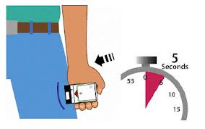
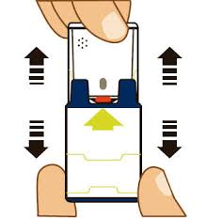
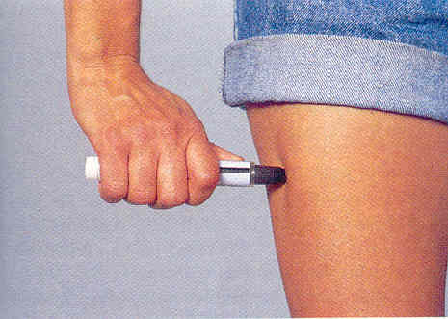
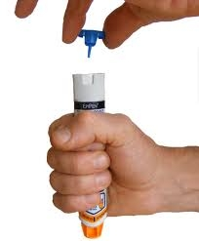
IF ALLERGEN LIKELY EATEN (OR STUDENT STUNG), FOLLOW THIS EPINEPHRINE PROTOCOL AT THE ONSET OF ANY OF THE ABOVE SYMPTOMS:
1. Administer Epi Auto-Injector: circle one: (0.15mg 0.3mg)
2. Have someone call 911 for ambulance, don’t hang up, and stay with student
- Administer Benadryl: circle one 12.5mg 25mg 37.5mg 50mg other____________
- Have student lie down with feet above level of head until EMS arrives
- Notify school and parent/guardian as soon as possible
Insert Picture if available

___________________________ _____________________________ ________________________
Parent Student (if applicable) School Nurse

